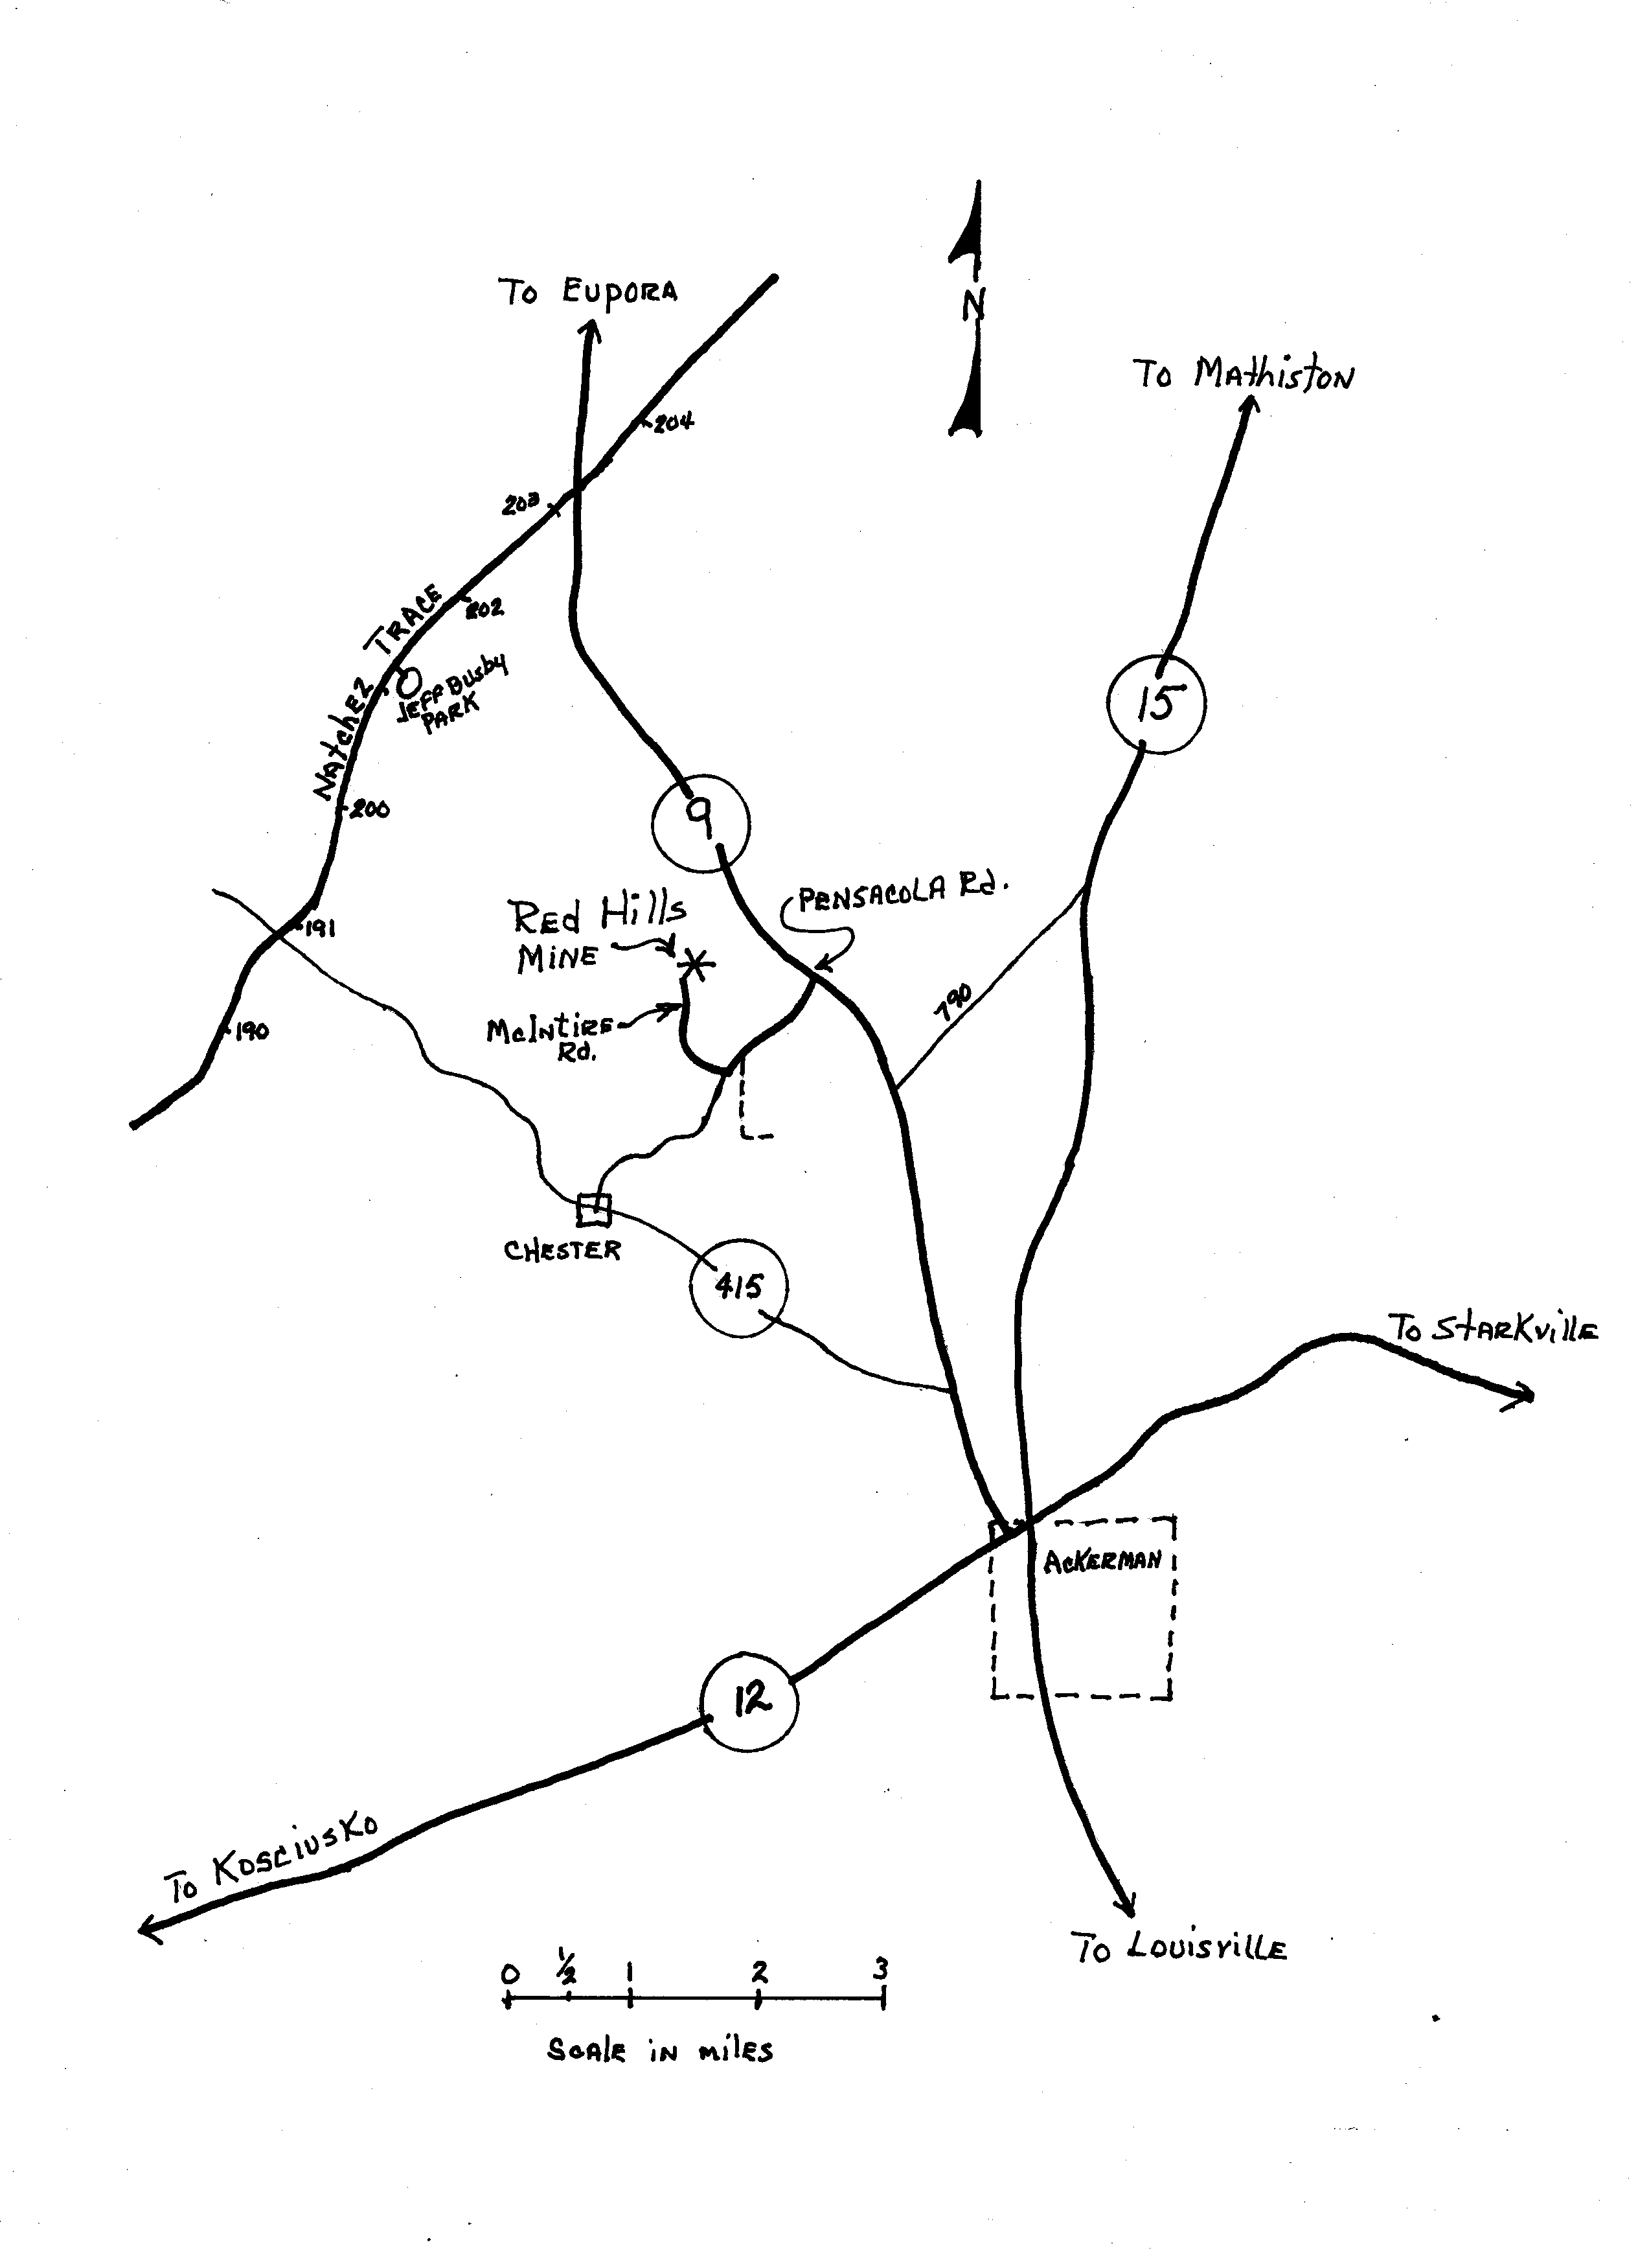
The Red Hills Mine is located at 1000 McIntire Road, Ackerman, MS. It is located off of Hwy 9 at Pensacola Road, approximately 4.8 miles north of Ackerman and 10.8 Miles south of Eupora. Turn west onto Pensacola Road (at the BP station), and drive 1.2 miles to McIntire Road (3rd paved road to the right). Turn north onto McIntire and drive 0.8 miles to the Red Hills Mine office.
Office: 662-387-5200

